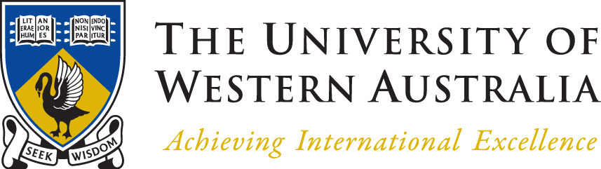

VISA2270 International Studio for Arts and Culture

BALI STUDIO 2014

APPLICATION TO REGISTER INTEREST
TO BE SUBMITTED BY APRIL 30 2014
INFORMATION SESSION Tuesday 15th APRIL AT 1 pm IN ROOM G.22 ALVA BUILDING

The Faculty of Architecture Landscape and Visual Arts is offering a mid-semester Bali Art and Culture.
The Bali Art and Culture program will be undertaken in June 29 – July 12, 2013. More information at http://paultrinidad.com.au/pages/isacfa.html

The unit is open to all students but it is recommended that students have completed a semester of University studies.

Scholarships
Study Abroad Scholarship applications close on Friday 25th April. We recommend you submit a scholarship application even if your place in the program has not yet been confirmed, as the application can always be withdrawn later. Go to https://hermes.international.uwa.edu.au/Default.aspx and complete the “Non-Exchange (Scholarship only) application”. Scholarships of $500 are available for students who meet the academic eligibility (65% overall average)

The unit code is VISA2270. Once your place is confirmed, you will receive instructions about adding this unit to your enrolment.

For more information about any of the studios including information please refer to the UWA handbook: http://units.handbooks.uwa.edu.au/units/visa/visa2270 and www http://paultrinidad.com.au/pages/isacfa.html Additional information about the curriculum for the unit is available by contacting Paul Trinidad. Otherwise see contact details below.
APPLICATION TO REGISTER INTEREST CLOSE 30 APRIL 2014
Please contact:
Ms. Carolyn Wood – Carolyn.Wood@uwa.edu.au
Phone 6488 2064

PLEASE NOTE:
STUDIO IS SUBJECT TO RECEIVING MINIMUM VIABLE NUMBERS. THE EXPRESSION OF INTEREST TO PARTICIPATE IN THE BALI STUDIO IS NOT A GUARANTEED PLACE. STUDIO FEE WILL BE $500 PLUS YOUR AIRFARE. THIS FEE INCLUDES ACCOMODATION TRANSPORT AFTER COMMENCEMENT, ART MATERIALS MUSEUM AND HERITAGE SITE FEES CEREMONIES.

Selection: Where more applications are received than places are available, selection may be by academic merit or interview.

You will be notified of developments after your Application to Register Interest has been received. More information and Bali Studio seminar’s to be held after May 5.

Other enquires to

Asst. Prof Paul Trinidad
paul.trinidad@uwa.edu.au

